Winter Learning Activities

1. Muffin-Tin Snowball Counting
Child Does:
Child draws a number card, counts out that many cotton balls or marshmallows, and places one in each section of a muffin tin.
Skills Your Child Builds:
- Counting & Number Sense: They practice counting objects and connecting the number they see to the amount they count.
- One-to-One Matching: Placing one “snowball” in each space helps them learn to count accurately.
- Fine Motor Skills: Picking up cotton balls or using tongs strengthens small hand muscles.
- Following Directions: They practice listening and completing simple steps.


2. Make-Your-Own Fake Snow
Child Does:
Child mixes baking soda with shaving cream or conditioner to create “snow,” then scoops, packs, and plays in it.
Skills The Child Builds:
- Language Development: Child uses describing words like soft, cold, squishy, fluffy.
- Social-Emotional Skills: Sensory play helps children feel calm and focused.
- Following Directions: Mixing ingredients helps them listen, follow steps, and work carefully.
- Imagination & Creativity: Children create snowmen, scenes, tracks, and mini worlds.
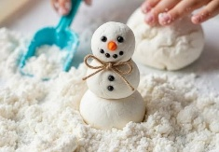

3. Marshmallow Snowflakes
Child Does:
Child builds a snowflake by sticking toothpicks or pretzels into marshmallows and creating branches.
Skills Your Child Builds:
- Fine Motor Strength: Pinching marshmallows and pushing them onto toothpicks builds finger strength needed for writing.
- Math & Geometry: They explore shapes, patterns, symmetry, and counting.
- Creative Thinking: They design and build their own unique snowflake.
- Problem Solving: They test ideas “Will this stand up?” “What happens if I add more?”


4. Marshmallow Counting with Dice
Child Does:
Your child rolls a die, identifies the number, and uses tongs or fingers to transfer the correct number of marshmallows from one bowl to another.
Skills The Child Builds:
- Counting & Subitizing: They practice counting or recognizing small quantities instantly.
- Number Identification: Rolling dice and matching the number builds number recognition.
- Fine Motor Development: Using tongs strengthens hand muscles and coordination.
- Comparison Skills: They can line up amounts and talk about “more,” “less,” or “the same.”
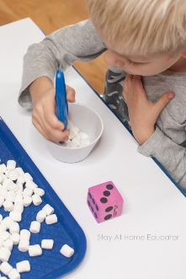

5. Snowball Toss
Child Does:
Child tosses cotton ball “snowballs” into cups or containers. Use different sizes or distances for added challenge.
Skills The Child Builds:
- Gross Motor: Improves hand-eye coordination and aiming.
- Math & Counting: Count the number of snowballs that land in the cup.
- Cognitive Skills: Teaches turn-taking and following directions.
- Language Skills: Encourage descriptive words like “throw,” “high,” and “soft.”
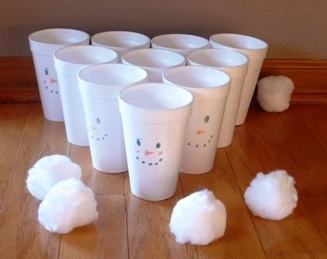

Why These Activities Matter
These winter activities aren’t just fun, they help children grow in math, motor skills, creativity, language, and problem-solving. They’re simple for families to do at home with everyday materials, and they support learning in a playful, engaging, and hands-on way.

