HOW TO PREPARE FOR FRIGID TEMPS
You should be prepared to take preventative steps to protect your residence when temperatures dip down into the 30s (or lower) and stay below the freezing mark for more than 24 hours. Below is a quick summary of some of the steps you may wish to consider. For additional how-to actions, check out YouTube videos and/or news channels.
Whether you are a homeowner or an apartment dweller, taking preventative steps before a freeze is important.
Remember the four P’s: Pipes, People, Pets, Plants
PROTECT PIPES
A hard freeze could result in frozen water pipes for homeowners, which can lead to water pipes inside your house bursting and leaking. If you live in an apartment, follow the steps outlined by the landlord to protect your pipes.
A prolonged cold spell will freeze unprotected water lines due to the expansion in the line which will cause small cracks in the pipes. Water leaks then occur when the temperature warms up. The Insurance Council of Texas (ICT) recommends taking the following steps to avoid frozen water pipes.
- Unhook any outdoor water hoses to your faucets, drain and store in a protected area.
- Wrap exposed faucets and pipes, including those outside the house or in unheated crawl spaces, attics, garages and other areas.
- Wrap outdoor pipes and faucets with newspaper, foam, rags or other insulating material. To keep the insulation in place, secure it with string, wire or tape.
- Check hardware stores for insulation products that fit over outside water faucets.
- Open doors under your bathroom and kitchens sinks to provide warm air circulation.
- Circulate the water in your home by dripping, even a trickle, in at least one sink. Water pipes that run along exterior walls are the most vulnerable.
- Keep the temperature at 55 degrees or warmer in your home, both day and night.
- If a leak is detected inside the home, shut off the water to the house immediately to prevent further damage and contact your plumber.
- Keep your garage door closed, especially if there are water supply lines located inside
- If you incur pipe damage, do not dispose of any items without the prior approval of your insurance adjuster.
- Pools and Spas: keep the pump running 24 hours and make sure all of the valves are open as well.
- Lawn irrigation sprinkler lines: check out YouTube videos for mitigation steps!
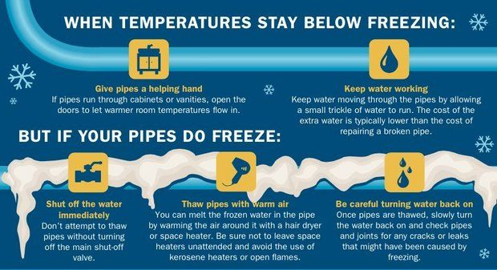
PROTECT PEOPLE
- Keep warm, stay inside if possible.
- If you need to go out, dress in layers and wear hats, gloves and an appropriate coat.
- Avoid overexertion, as cold weather puts added strain on your body.
- Never place a space heater on top of furniture or near water.
- Keep heat sources at least 3 feet away from furniture and drapes.
- Never leave children unattended near a space heater.
- Check on your neighbors, especially the elderly, to see whether you can assist them with preventive winter weather actions

Protect yourself from carbon monoxide (CO) poisoning by installing a battery-operated CO detector and never use generators, grills, camp stoves, or similar devices indoors.
It is also recommended that you prepare your car for winter. Have your car serviced and add antifreeze as needed. Make sure battery terminals are clean and tightened -- you may even want to clean around terminals with an old toothbrush and a homemade mixture of baking soda and water. Keep in mind that you should replace your battery every three to four years. Make certain windshield wipers and defrosters are in good working order and the window washer reservoirs are filled.
Finally, keep emergency supplies at hand and stay informed about the weather conditions in our area. You can get additional information by visiting www.hcoem.org. The “Ready Harris” website has wonderful winter weather tips.

PROTECT PETS
- Bring pets inside, and move other animals or livestock to sheltered areas.
- Keep adequate food and water available.
It's important to remember that a pet's age, breed or illness may affect how they tolerate the cold weather. The Houston SPCA advises that it is best that all pets live indoors due to these unpredictable weather conditions.
- Housing: Provide proper shelter for your pet whether they live indoors or outdoors. Indoor pets should have their bed or crate placed in a safe and warm place that is away from drafts. Outdoor pets should have a well-insulated house that is wind and waterproof resistant and elevated off the ground so wind and moisture can't leak inside. Install a door flap to protect against drafts and gusts of wind. Extra blankets and straw will also help to increase your pet's warmth. Room and floor heaters should be kept away from your pet as they are an obvious fire hazard and can cause serious injuries as well.
- Food & Water: Make sure to provide fresh, clean water for your pet every day. Outdoor pets need to consume 25 to 50 percent more calories than usual because the cold weather tends to deplete their energy. Make sure to talk to your veterinarian to make sure what is right for your pet.
- Cars are Refrigerators: A car can act as refrigerator in the winter. Never leave your dog or cat alone in a car during the winter months as they will freeze to death.
- Cats and Cars: Keep your cats indoors during the winter. Not only can outdoor cats freeze, they sometimes sleep under the hoods of cars to stay warm. When the motor is started, the cat can be injured or killed by the fan belt. Give an outdoor cat a chance to escape by banging loudly on the car hood before starting your car.
- Warmth: If you have a short-haired breed of dog, consider getting a sweater with a high collar or turtleneck with coverage from the base of the tail to the belly to keep them warm. Never shave your dog down to the skin in the winter months as a longer coat will provide more warmth. The same goes for your cat!
- Antifreeze: Dogs and cats are attracted to the sweet smell and taste of antifreeze which contains ethylene glycol. A tiny lick can kill your dog or cat so make sure to check your car for leaks on your driveway or gutter. Keep containers tightly closed and clean up spills immediately. Check your local retailer for "pet safe" antifreeze.
- Rodenticides: Rat and mouse poisons are commonly used during the winter months. Place them out of reach as they can cause fatal bleeding or kidney failure in your pet.

PROTECT PLANTS
- Cover your plants with a frost cloth because it lets the plant breathe, but also holds a lot of heat. If you can't find a frost cloth, a sheet or a blanket works well. Just make sure the material allows your plants to breathe and that it isn't just sitting on top of the plants. You want to wrap it around and below the plant so no wind enters. A frost cloth costs around $15.
- If there are potted plants you cannot move inside, then move potted plants to a spot where they're protected from the north wind. Wind causes a lot of frost damage, not necessarily the cold temperatures.
- Spread at least two to three inches of mulch to protect the roots of plants and trees. You might get frost damage on top of the plant, but if the roots are protected then the roots can come back in the spring. Mulch will cost you around $5/bag.
- Use water on plants. It goes against common sense, but watering your plants actually protects them from the cold. Water in the ground is going to keep the roots from getting frost damage.
- Avoid common mistakes with plants:
  - Do not cover plants in plastic
  - Do not cut back dead-looking parts of plants after a cold spell.
  - Do not put mulch too close to plants and trees.
  - Do not wait until it's too cold to cover your plants.

